Module 12 – Location Graph

Exploratory Data Analysis

*In this section, you should perform some data analysis on the data provided to you. Please format your findings in a visually pleasing way and please be sure to include these cuts:*

**

I took averages of the stores lat and long to get a new dc.

Model Formulation

MIN: SQRT(((37.07-Xi)^2)+(-93.67-Yi)^2)) + SQRT (((36.07-Xi)^2)+(-111.1-Yi)^2)) + SQRT(((36.82-Xi)^2)+(-85.87-Yi)^2)) + SQRT(((37.44-Xi)^2)+(-101.83-Yi)^2)) + SQRT(((43.54-Xi)^2)+(-116.5-Yi)^2)) + SQRT(((37.06-Xi)^2)+(-116.39-Yi)^2)) + SQRT(((38.08-Xi)^2)+(-107.64-Yi)^2)) + SQRT (((35.61-Xi)^2)+(-116.97-Yi)^2))

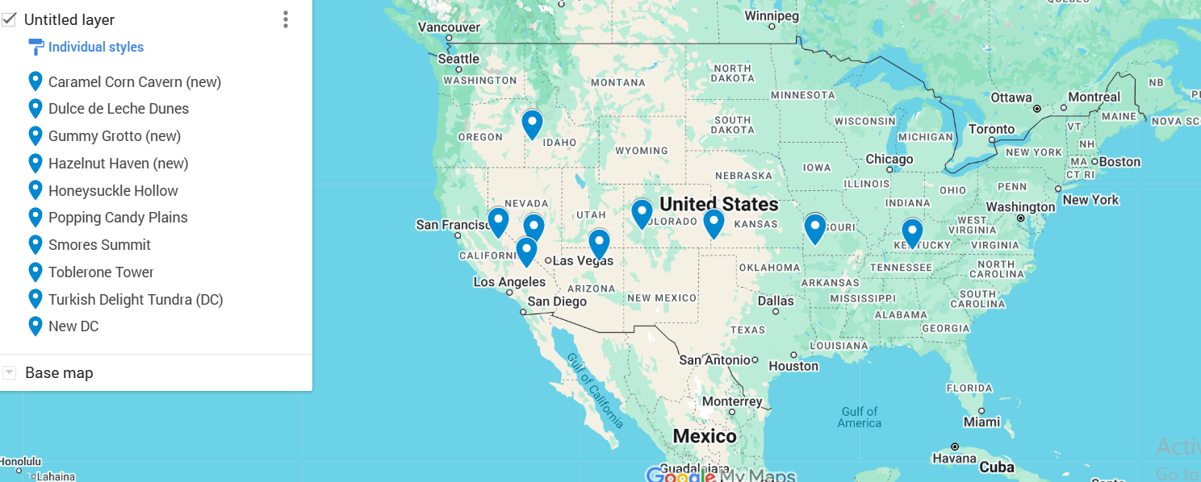

Model Optimized for Distance Reduction from DC to Store



Model with Stipulation

*Please copy the tab of your original model before continuing with the next part to avoid messing up your original solution.*

*You should notice that while distance is minimized between each store and each DC, there is a discrepancy between how much demand is serviced between each DC (i.e. one DC may service a lot more demand than others). Please:*

1. *Choose one: B*
2.  *My model is recommending a better optimization based on distance and demand for the new DC. This means that the new DC will slightly favor cities with more demand, making it more optimal.*
3. *Explain the changes to your Solver/Model. – better objective solution*